

CampusNote Pro
REQUIREMENTS ELICITATION AND ANALYSIS DOCUMENT

Student Number | Name and Surname | Role | Photo
220303008 | Pelin Zeynep Kaya | Leader
220303012 | Arjin İlhan | Developer
220303014 | Mustafa Baver Çalış | Developer | 
220303006 | Hüseyin Fidan | Tester | 

Document Name | : CampusNotePro_READ.docx
Version No | : 3.0
Version Date | : 05.05.2026

DOCUMENT APPROVAL INFORMATION
Contributors | Pelin Zeynep Kaya (Leader)  Hüseyin Fidan (Tester)  Arjin İlhan (Developer)  Mustafa Baver Çalış (Developer) | Sign
Reviewer-1 (LLM) | Gemini Pro 3.1 | ☐
Reviewer-2 (LLM) | NotebookLM | ☐
Reviewer-3 | Arjin İlhan
Reviewer-4 | Mustafa Baver Çalış
Reviewer-5 | Hüseyin Fidan
Quality Manager |  | ☐
Stakeholder-1 |  | ☐
Stakeholder (Instructor) | Haluk Gümüşkaya | ☐

CHANGE RECORDS
Version | Comments | Date
1 | Initial Draft | 22/04/2026
2 | Peer Review & Analysis Refinement | 28/04/2026
3 | Final Validation & Traceability Matrix | 04/05/2026

DISTRIBUTION RECORDS
Distribution No | Version No | Comments | Distribution Method
 |  |  | Upload to Google Classroom

Contents
1. Introduction. 5
1.1. Objectives of Requirements Engineering 5
1.2. Purpose of the Document 5
1.3. Project Scope 5
1.4. Objectives and Success Criteria 5
1.5. Stakeholders 6
1.6. System Context 6
2. Requirements Elicitation 7
2.1. Elicitation Methods and Tools 7
2.2. High-Level Requirements Summary 7
2.3. Functional Requirements 7
2.4. Non-Functional Requirements 8
2.5. Assumptions 9
3. Requirements Analysis 9
3.1. Scenarios 9
3.2. Use Case Models 10
3.3. Data Models (Entity-Relationship (ER Diagrams)) 12
3.4. Problem Domain Class/Object Models 14
3.5. Dynamic Models 15
3.6. Component, Package and Deployment Models 17
3.7. System Architecture 18
3.8. User Interfaces 19
4. Requirements Validation 23
4.1. Validation Approach 23
4.2. Acceptance Criteria 23
5. Traceability 25
6. Conclusion 26
7. References 26
8. Descriptions, Abbreviations, and Dictionary 28
8.1. Descriptions 28
8.2. English Abbreviations 28

- Introduction

Objectives of Requirements Engineering
Requirements Engineering (RE) is the systematic process of discovering, documenting, and maintaining the specific needs of a system's users. For CampusNote Pro, this discipline is vital because it ensures the platform effectively solves the problem of information loss students face due to fragmented communication channels while incentivizing active participation. By utilizing elicitation to gather student needs, analysis to structure those needs, validation to ensure the system is realistic, and management to track progress, we establish a professional foundation that avoids the superficiality of typical academic projects. Furthermore, by utilizing gamification, we aim to transform the archiving process into a rewarding experience, encouraging students to provide high-quality materials in exchange for academic rank and rewards.
Key activities within this process include:
- Requirements Elicitation: Collecting needs from students and faculty to understand the academic hierarchy and identifying pain points in existing sharing behaviors.
- Requirements Analysis: Refining gathered needs into technical models like Use Case and Data Diagrams to ensure structural integrity.
- Validation: Ensuring the requirements are realistic, consistent, and testable before implementation begins.
- Requirements Management: Maintaining a Traceability Matrix to link every student need to a specific system feature, reward trigger, or test case.

Purpose of the Document
The primary purpose of this Requirements Elicitation and Analysis Document (READ) is to formally initiate the development process for CampusNote Pro. This document establishes a strong foundation for the system's design by detailing student-oriented needs and organizational artifacts. It serves as a synchronized roadmap for the project leader, developers, and testers to ensure the system remains consistent throughout the 10-week development period.

Project Scope
The scope focuses on a centralized, hierarchical platform that empowers students to archive and verify study materials.
In-Scope:
- A structured repository for student notes indexed by Faculty and Course Code.
- A verification system driven by an Academic Ranking Algorithm.
- Gamification Engine: User Ranking system and "CampusCoin" distribution.
- Role-Based Access Control and a responsive web interface.
Out-of-Scope:
- Development of native mobile applications for iOS or Android.
- Built-in tools for creating or editing documents within the platform.
- Marketplace features for financial transactions between students.

Objectives and Success Criteria
The ultimate goal of CampusNote Pro is to transform academic collaboration into a traceable and verified knowledge ecosystem for the student body. We aim to provide a reliable environment where academic materials move through a transparent lifecycle from "Draft" to "Published" status.
The success of the system will be measured by its ability to maintain high availability and deliver document rendering times of less than 2 seconds, especially during peak exam periods. Furthermore, 100% of the core student requirements must be linked to automated verification tests to guarantee the platform's reliability.
Table 1.1. Objectives and measurable success criteria.

Objective | Measurable Success Criteria
System Performance | The system shall deliver document preview and rendering times of ≤ 2.0 seconds during peak traffic periods.
Platform Reliability | The system shall maintain an operational cloud availability (uptime) of at least 99.9%.
Content Quality | The platform shall maintain a global average AI Verification Score of ≥ 80/100 across all submitted documents.
Technical Traceability | 100% of documented Functional Requirements shall be bi-directionally traceable to automated unit and integration tests.
User Motivation (Gamification) | At least 30% of users who upload a document will subsequently upload a second document to earn additional CampusCoins.
Data Security | The system shall experience 0 unauthorized privilege escalation incidents to the Administrative Dashboard.

Stakeholders
Table 1.2. Stakeholder list and expectations.

Stakeholder | Role | Importance | Expectations
Student (Uploader) | Primary User / Contributor | Critical | Easy document upload process, accurate categorization (Faculty/Course Code), and earning CampusCoins/virtual ranks through successful AI verification.
Student (Consumer) | Primary User / Consumer | Critical | Fast access to high-quality notes, document rendering in ≤ 2.0 seconds, and a reliable search/filter system.
System Administrator | Moderator / Operations | Critical | A secure dashboard to manage flagged documents, monitor cloud storage capacity, and suspend accounts violating academic integrity.
Course Professor | Client / Evaluator | Critical | Professional documentation (READ), adherence to SWEBOK v4.0 standards, and 100% consistency between UML models and text.
Project Team | Developers & Managers | Critical | A clear technical roadmap, established bi-directional traceability, and successful system deployment on Heroku.
Istanbul Arel University | Institutional Host | Major | Preservation of academic knowledge and the elimination of information silos across social media groups.

System Context
CampusNote Pro operates as a centralized, web-based Software-as-a-Service (SaaS) platform hosted on the Heroku cloud infrastructure. The system is designed with a strict client-server architecture, assuming a stable internet connection for REST API consumption.
The application establishes clear architectural boundaries and interfaces with the following distinct environments:
- Client Interface: End-users interact with the system via standard modern web browsers using a responsive frontend styled with Tailwind CSS.
- Application Server: The core business logic, gamification engine, and API routing are handled by a Java Spring Boot backend deployed on Heroku.
- Relational Persistence: A PostgreSQL database handles the persistent storage of structured academic metadata, user credentials, and gamification telemetry (e.g., CampusCoins, virtual ranks).
- Object Storage (External): Amazon Web Services (AWS) S3 is utilized exclusively for the secure physical storage and retrieval of uploaded PDF document files.
- AI Verification Engine (External): The system continuously communicates with an external AI Ranking Service—developed in Python using the PyTorch machine learning framework—via REST API to extract text, calculate keyword density, and return an automated 0-100 quality score for document moderation.

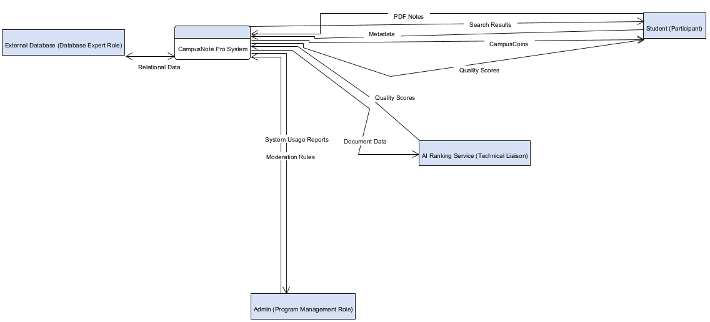
Figure 1.1. System Context Diagram

- Requirements Elicitation
This section documents the primary needs of the CampusNote Pro platform, derived from stakeholder analysis and the specific academic context of Istanbul Arel University.

Elicitation Methods and Tools
The following methods were used to capture requirements during the development cycle:
- Existing System Analysis: Analysis of fragmented sharing behavior within WhatsApp and Telegram groups to identify common data loss points. Our analysis identified three critical information loss patterns:
  - Temporal Decay: Crucial exam notes are pushed out of view by daily chat volume within 48 hours, making them difficult to retrieve.
  - Metadata Absence: Files are shared without clear Course Codes or Department labels, rendering standard keyword search ineffective.
  - The Trust Gap: The absence of a verification mechanism forces students to manually cross-check PDF accuracy, leading to wasted study time.
- Scenario-Based Elicitation: Creation of narrative interaction paths to determine how users navigate the academic hierarchy.
- Proxy Stakeholder Brainstorming: The internal project team acted as proxy students to define core pain points regarding resource accessibility.
Traceability and Mapping Rule: To ensure high-level bi-directional traceability and simplify modeling in Visual Paradigm, the textual specification is strictly decoupled from the Use Case numbering. Instead, every unique Requirement ID (e.g., FR-ST-33) must be tagged directly onto its corresponding conceptual element (Use Case bubble, Database Column, or Activity Node) within the UML diagrams. This guarantees that no architectural model is drawn without a justifying business requirement.

High-Level Requirements Summary
The table below provides a high-level summary of the essential requirements that form the backbone of the CampusNote Pro architecture.
Table 2.1. High-level requirements summary.
ID | Description | Type
FR-ST-15 | The system shall restrict study note uploads exclusively to the PDF file format. | Functional
FR-DOC-17 | The system shall categorize documents based on the official Istanbul Arel University Faculty hierarchy. | Functional
FR-DOC-28 | The system shall transition document status to "Published" only after assigned AI quality scores meet the passing threshold. | Functional
FR-ST-44 | The system shall initiate a secure PDF download upon a user selecting the retrieval icon for a published document. | Functional
NFR-DOC-65 | The system shall maintain an operational cloud availability (uptime) of at least 99.9%. | Non-Functional
NFR-ST-69 | The system shall generate and render document previews in ≤ 2.0 seconds. | Non-Functional
CON-TECH-74 | The system shall utilize the Heroku cloud platform for final production hosting. | Constraint
CON-TECH-76 | The system shall be delivered as a responsive web SaaS, excluding native mobile application development. | Constraint

Functional Requirements

Table 2.2. Identity & Access Management
ID | Name | Description | Priority
FR-ST-01 | User Authentication | The system shall authenticate users using an "@arel.edu.tr" email domain. | Must Have
FR-ST-02 | Invalid Credentials | The system shall deny login attempts containing incorrect credentials. | Must Have
FR-ST-03 | Login Error | The system shall display an error message upon a denied login attempt. | Must Have
FR-ST-04 | Password Recovery | The system shall provide a password reset link via email. | Should Have
FR-ST-05 | Session Termination | The system shall terminate the active session upon clicking the sign-out button. | Must Have

Table 2.3. Dashboard & User Analytics
ID | Name | Description | Priority
FR-ST-06 | Department Display | The system shall display the user's enrolled academic Department on the dashboard navigation bar. | Should Have
FR-ST-07 | Academic Year Display | The system shall display the user's current academic year on the dashboard navigation bar. | Should Have
FR-ST-08 | Registration Date | The system shall display the user's account creation date on their profile. | Could Have
FR-ST-09 | Upload Analytics | The system shall display the total count of documents uploaded by the user. | Should Have
FR-ST-10 | Download Analytics | The system shall display the aggregated total of downloads received across all of the user's documents. | Should Have
FR-ST-11 | Upload History | The system shall display a chronological list of the user's previously uploaded documents. | Must Have
FR-ST-12 | History Status | The system shall display the current verification status (e.g., Draft, Published) alongside each document in the upload history list. | Must Have
FR-ST-13 | Like Analytics | The system shall display the aggregated total of "Likes" received across all of the user's documents on their profile. | Should Have
FR-ST-14 | Theme Toggle | The system shall permit users to toggle the interface rendering between Light and Dark visual themes. | Could Have

Table 2.4. Document Ingestion Subsystem
ID | Name | Description | Priority
FR-ST-15 | PDF Enforcement | The system shall allow students to upload documents strictly in PDF format. | Must Have
FR-ST-16 | Size Restriction | The system shall reject uploaded files exceeding 20MB. | Should Have
FR-DOC-17 | Faculty Classification | The system shall categorize documents based on the official Arel University Faculty list. | Must Have
FR-DOC-18 | Department Filtering | The system shall filter available Department options based on the previously selected Faculty. | Must Have
FR-ST-19 | Course Code Entry | The system shall require the input of a valid Course Code prior to document submission. | Must Have
FR-ST-20 | Initial Status | The system shall assign a "Draft" status to a document immediately upon successful upload. | Must Have
FR-ST-21 | Submission Validation | The system shall disable the "Upload Document" button until a valid PDF file is provided and all mandatory categorization fields are selected. | Must Have
FR-ST-22 | Upload Cancellation | The system shall abort the upload process and close the modal upon the user clicking the "Cancel" button. | Could Have

Table 2.5. AI Academic Ranking Algorithm
ID | Name | Description | Priority
FR-ST-23 | AI Service Trigger | The system shall transmit the "Draft" PDF document to the external AI Ranking Service. | Must Have
FR-ST-24 | Processing Status | The system shall assign an "Under Review" status to documents that are actively being processed by the AI Ranking Service. | Must Have
FR-ST-25 | Text Extraction | The system shall extract text content from the submitted PDF document. | Must Have
FR-ST-26 | Keyword Comparison | The system shall compare extracted text against the course-specific academic keyword dictionary. | Must Have
FR-ST-27 | Quality Scoring | The system shall calculate an integer quality score ranging from 0 to 100 based on keyword density. | Must Have
FR-DOC-28 | Publication Rule | The system shall change the document status to "Published" if the score is greater than or equal to the passing threshold. | Must Have
FR-DOC-29 | AI Rejection Routing | The system shall change the document status to "Flagged" and route it to the Moderation Queue if the AI quality score is strictly less than the passing threshold. | Must Have
FR-ST-30 | Verification Notice | The system shall notify the uploader regarding the final AI verification status. | Should Have

Table 2.6. Gamification & Engagement
ID | Name | Description | Priority
FR-ST-31 | CampusCoin Display | The system shall display the user's total CampusCoin balance on the dashboard. | Should Have
FR-ST-32 | Rank Display | The system shall display the user's current virtual rank on the dashboard. | Could Have
FR-ST-33 | Reward Calculation | The system shall calculate the document's CampusCoin reward by multiplying its associated Course's credit value (AKTS) by 10. | Must Have
FR-ST-34 | Coin Distribution | The system shall add the calculated CampusCoin reward to the uploader's account balance immediately upon the document achieving "Published" status. | Must Have
FR-ST-35 | Rank Evaluation | The system shall evaluate the user's total CampusCoin balance against the virtual rank thresholds. | Should Have
FR-ST-36 | Rank Upgrade | The system shall upgrade the user's virtual rank when their coin balance meets the next configured threshold. | Could Have
FR-ST-37 | Document Liking | The system shall permit users to cast a "Like" on a document possessing a "Published" status. | Should Have
FR-ST-38 | Leaderboard Display | The system shall display a globally ranked leaderboard of users, sorted descending by their total CampusCoin balance. | Should Have

Table 2.7. Search, Retrieval, and Navigation
ID | Name | Description | Priority
FR-ST-39 | Keyword Input | The system shall provide a text input field for keyword-based document searching. | Must Have
FR-ST-40 | Verified Filter | The system shall restrict search results exclusively to documents possessing a "Published" status. | Must Have
FR-ST-41 | Faculty Filter | The system shall filter search results based on a selected Faculty parameter. | Should Have
FR-ST-42 | Result Sorting | The system shall sort search results by the highest download count. | Should Have
FR-ST-43 | Document Preview | The system shall display a thumbnail preview consisting of the first page of the PDF. | Could Have
FR-ST-44 | File Retrieval | The system shall initiate a PDF file download upon clicking the download icon. | Must Have
FR-ST-45 | Download Tracking | The system shall increment the document's download counter by one upon a successful retrieval. | Could Have
FR-ST-46 | View Tracking | The system shall increment the document's view counter by one each time a user renders the document's preview thumbnail. | Could Have

Table 2.8. Administrative Operations
ID | Name | Description | Priority
FR-ST-47 | Restricted Access | The system shall deny access to the Admin Dashboard for any user who does not possess the Administrator role. | Must Have
FR-ST-48 | User Listing | The system shall display a data table of registered student accounts. | Should Have
FR-ST-49 | Admin User Search | The system shall provide a text input field within the Admin Dashboard for administrators to filter the user table by name or email address. | Should Have
FR-ST-50 | Account Suspension | The system shall permit administrators to change a user's account status to "Suspended". | Should Have
FR-ST-51 | Suspension Enforcement | The system shall deny login capabilities to "Suspended" accounts. | Must Have
FR-ST-52 | Moderation Queue | The system shall display a list of all documents possessing a "Flagged" status within the Admin Dashboard. | Must Have
FR-ST-53 | Moderation Metric | The system shall display the aggregated total count of currently "Flagged" documents on the Admin overview dashboard. | Could Have
FR-ST-54 | Moderation Context | The system shall display the document's calculated AI Quality Score alongside its entry in the moderation queue. | Should Have
FR-ST-55 | Content Deletion | The system shall permit administrators to delete documents from the repository. | Must Have
FR-ST-56 | Flag Dismissal | The system shall permit administrators to dismiss reports on a flagged document, removing it from the moderation queue while retaining its "Published" status. | Must Have

Table 2.9. System Operations
ID | Name | Description | Priority
FR-ST-57 | Automated Flagging | The system shall change a document's status to "Flagged" when it accumulates 5 negative user reports. | Could Have
FR-ST-58 | Audit Logging: Deletion | The system shall write a timestamped log entry to the audit file immediately upon an administrator deleting a document. | Should Have
FR-ST-59 | Audit Logging: Suspension | The system shall write a timestamped log entry to the audit file immediately upon an administrator suspending a user account. | Should Have
FR-ST-60 | Audit Logging: Configuration | The system shall write a timestamped log entry to the audit file immediately upon an administrator modifying the global AI passing threshold. | Should Have
FR-ST-61 | Audit Logging: Dismissal | The system shall write a timestamped log entry to the audit file immediately upon an administrator dismissing a document report. | Should Have
FR-ST-62 | Audit Trail Display | The system shall display a chronological list of recent administrative log entries on the Admin Dashboard. | Should Have
FR-ST-63 | Storage Telemetry | The system shall display the total database storage consumption in gigabytes (GB) on the Admin Dashboard. | Could Have
FR-DOC-64 | Threshold Configuration | The system shall permit the Administrator role to modify the global AI algorithm passing score. | Should Have

Non-Functional Requirements

Specific Quality Requirements
Quality attributes define the non-behavioral aspects of the system, such as reliability and security, which are essential for maintaining user trust in an academic environment.

Table 2.8. Specific quality requirements.
ID | Name | Description | Priority
NFR-DOC-01 | Operational Uptime | The system shall maintain an operational availability of at least 99.9%. | Must Have
NFR-ST-02 | Verification Integrity | The system shall ensure 100% of "Published" notes pass the Ranking Algorithm. | Must Have
NFR-ST-03 | Password Security | The system shall encrypt 100% of user passwords using BCrypt hashing. | Must Have
NFR-ST-04 | Data Persistence | The system shall perform automated database backups every 24 hours. | Should Have

Performance Requirements
Performance requirements define the speed and capacity constraints. These metrics are critical during high-traffic periods, such as final exam weeks.

Table 2.4. Performance requirements.
ID | Name | Description | Priority
NFR-ST-05 | Preview Latency | The system shall render document previews within 2.0 seconds. | Should Have
NFR-ST-06 | Search Response | The system shall return search results within 500 milliseconds. | Must Have
NFR-ST-07 | Algorithm Throughput | The system shall process the ranking analysis in under 5.0 seconds per 10MB file. | Must Have

Constraints
Performance requirements define the speed and capacity constraints. These metrics are critical during high-traffic periods, such as final exam weeks.

Table 2.5. Constraints.
ID | Name | Description | Priority
CON-TECH-01 | Development Framework | The system shall be developed using the Java Spring Boot framework. | Must Have
CON-TECH-02 | Persistence Layer | The system shall utilize a PostgreSQL relational database. | Must Have
CON-TECH-03 | Hosting Infrastructure | The system shall be deployed on the Render cloud platform. | Must Have
CON-TECH-04 | Interface Styling | The system shall implement user interfaces using Tailwind CSS. | Should Have
CON-TECH-05 | Deployment Boundary | The system shall exclude native mobile application development. | Won't Have
CON-TECH-06 | Object Storage | The system shall utilize Amazon Web Services (AWS) S3 for the physical storage of uploaded PDF document files. | Must Have

Assumptions
Assumptions are conditions considered to be true for the purpose of the requirement analysis, acknowledging factors outside the direct control of the project team.
Table 2.6. Assumptions.
ID | Name | Description
ASM-ENV-01 | Connectivity | It is assumed that users possess stable internet connectivity for cloud platform access.
ASM-DOC-02 | University Hierarchy | It is assumed that the university provides an up-to-date hierarchy of all faculties and departments.
ASM-ST-03 | User Motivation | It is assumed that students are motivated to upload high-quality notes by virtual ranks and CampusCoins.
ASM-TECH-04 | Resource Availability | It is assumed that the Heroku cloud platform provides sufficient resources to support document rendering times.
ASM-ST-05 | Algorithmic Autonomy | It is assumed that the Ranking Algorithm is capable of evaluating documents without manual human intervention.

- Requirements Analysis

Scenarios
The following scenarios describe realistic interactions between users and the system to illustrate how the requirements solve real-world problems.

Scenario 1: Successful Document Upload

- Actor: Student (Uploader)
- Goal: Share a high-quality study note with peers to earn CampusCoins and improve their academic rank
- Steps:
- Login: Student authenticates using their @arel.edu.tr email. (FR-ST-01)
- Navigation: Student selects "Faculty of Engineering" and "Course: CS101." (FR-DOC-09)
- Upload: Student uploads a PDF summary of the course. (FR-ST-07)
- Analysis: The system automatically triggers the Academic Ranking Algorithm. (FR-ST-13)
- Scoring: The algorithm scans for keywords and assigns a quality score of 85/100. (FR-ST-15)
- Publication: Since 85 exceeds the threshold, the system changes the status to "Published." (FR-ST-16)
- Reward: The system deposits 10 CampusCoins into the Student's profile. (FR-ST-17)
Scenario 2: Low-Quality Content Rejection

- Actor: Student (Uploader)
- Goal: Attempt to upload a low-quality, corrupted, or irrelevant file.
- Steps:
  - Upload: Student uploads a PDF file containing only one sentence. (FR-ST-07)
  - Analysis: The system executes the Academic Ranking Algorithm. (FR-ST-13)
  - Failure: The algorithm detects a "Low Keyword Density" and assigns a score of 10/100. (FR-ST-15)
  - Rejection: The system retains the file in "Draft" status and does not publish it. (FR-ST-16)
  - Notification: The system notifies the user that the document failed verification.
  - No Reward: The user’s CampusCoin balance remains unchanged.

Scenario 3: Hierarchical Keyword Search and Download
- Actor: Student (Consumer)
- Goal: Find and download verified materials for an exam.
- Steps:
  - Search: Student enters "Calculus 1" into the search bar. (FR-ST-19)
  - Filter: Student filters the results to only show "Faculty of Engineering." (FR-ST-20)
  - Selection: Student sorts the results by "Most Downloaded" to find the best note. (FR-ST-21)
  - Preview: Student views the thumbnail preview of the first page. (FR-ST-22)
  - Download: Student clicks download; the system serves the PDF and increments the download counter. (FR-ST-12)

Use Case Models
The detailed use case descriptions below provide the logic and flow for technical implementation, ensuring a clear understanding of system-actor interactions.
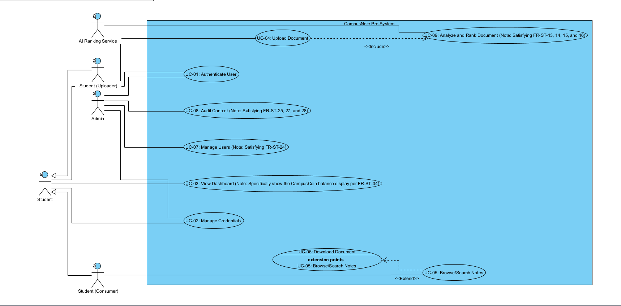
Figure 3.1. Use Case Diagram.

Use Case 1: UC-04 Authenticate User
Table 3.1. Use case description for UC-04 Authenticate User.
Field | Description
Use Case Name | Authenticate User
Actor(s) | Student, Instructor, Admin
Description | The user logs into the system using university credentials.
Preconditions | The user has an active university account.
Main Flow | 1. User enters username.  2. User enters password.  3. System validates credentials.  4. System grants access.
Alternative Flow | 1. Invalid credentials entered; system displays error message.
Postconditions | User is logged in and redirected to the dashboard.

Use Case 2: UC-05 Upload Document
Table 3.2. Use case description for UC-05 Upload Document.
Field | Description
Use Case Name | UC-05 Upload Document
Actor(s) | Student (Uploader)
Description | The user uploads a PDF study note and categorizes it strictly by Faculty, Department, and Course Code.
Preconditions | The user is successfully authenticated into the system.
Main Flow | 1. User selects Upload. 2. User selects a PDF file. 3. User categorizes by Faculty and Course. 4. User confirms upload. 5. System saves file as Draft.
Alternative Flow | 1. If file is not PDF, system rejects upload and displays error.
Postconditions | Document is stored in Draft status pending AI verification.

Use Case 3: UC-07 Verify, Publish and Reward
Table 3.3. Use case description for UC-07 Verify, Publish and Reward.
Field | Description
Use Case Name | UC-07 Verify, Publish and Reward
Actor(s) | AI Ranking Algorithm (System)
Description | The AI evaluates a draft document, publishes it if score is above 80, and awards CampusCoins.
Preconditions | A document exists with Draft status.
Main Flow | 1. AI algorithm evaluates document.  2. Algorithm assigns quality score.  3. System checks if score is passing.  4. System changes status to Published.  5. System awards CampusCoins to uploader.
Alternative Flow | 1. If score is failing, system rejects document and leaves it as Draft.
Postconditions | Document is published and user is rewarded, or it is rejected.

Use Case 4: UC-08 Keyword Search and Download
Table 3.4. Use case description for UC-08 Keyword Search and Download.
Field | Description
Use Case Name | UC-08 Keyword Search and Download
Actor(s) | Student (Consumer)
Description | The user searches for published notes using keywords and downloads a verified file.
Preconditions | User is authenticated and published documents exist.
Main Flow | 1. User enters keyword.  2. System searches metadata.  3. System displays matching documents.  4. User selects a document to download.  5. System serves the PDF file.
Alternative Flow | 1. If no matches found, system displays “No Results Found” message.
Postconditions | User successfully downloads the document.

Data Models (Entity-Relationship (ER Diagrams))
The Data Model for CampusNote Pro represents the hierarchical structure of Istanbul Arel University's academic departments and the lifecycle of shared academic documents.

Entity Descriptions and Attributes
Table 3.5. Entity descriptions and database attributes
Entity | Attributes | Primary Key (PK) | Foreign Key (FK)
User | userId, fullName, email, passwordHash, role, coinBalance, rank | userId | None
Faculty | facultyId, facultyName | facultyId | None
Department | departmentId, departmentName | departmentId | facultyId
Course | courseId, courseCode, courseName | courseId | departmentId
Document | docId, title, filePath, status, uploadDate | docId | userId, courseId
RankingResult | rankingId, score, feedback, verifiedAt | rankingId | docId
Flag | flagId, reason, status, createdAt | flagId | userId, docId

Relationships
- Faculty - Department: One Faculty contains many Departments (1:N).
- Department - Course: One Department offers many Courses (1:N).
- User - Document: One User (Student/Instructor) can upload many Documents (1:N).
- Course - Document: One Course acts as a repository for many Documents (1:N).
- Document - RankingResult: Each Document undergoes a verification process resulting in one Ranking score (1:1).
- User - Flag: One User (Student) can report many documents, creating multiple Flags (1:N).

- Document - Flag: One Document can be flagged multiple times by different users for review (1:N).

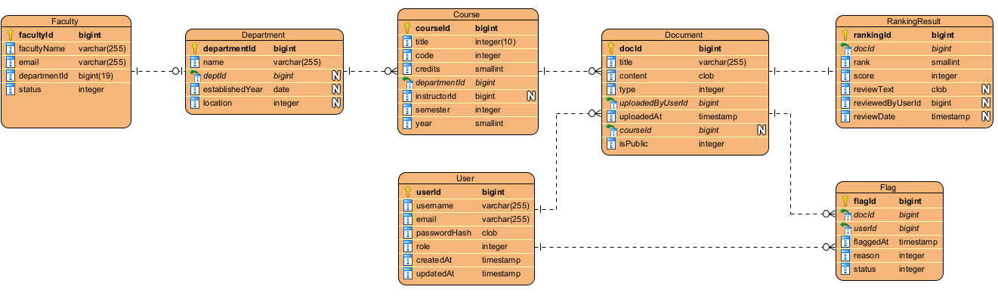
Figure 3.2. ER Data Model representing the database structure of CampusNote Pro.

Problem Domain Class/Object Models
This class diagram represents the main problem domain classes of the CampusNote Pro system. It describes the static structure from an analysis perspective, focusing on real-world concepts and behaviors without implementation details .

Problem Domain Classes:
- Student:
  - Attributes: +userId, +coinBalance, +rank
  - Operations: +uploadDocument(), +downloadDocument(), +searchKeyword(), +reportDocument()
- Admin:
  - Attributes: +adminId, +role
  - Operations: +manageUserAccount(), +reviewFlaggedContent(), +deleteDocument()
- Document:
  - Attributes: +docId, +title, +status, +qualityScore
  - Operations: +updateStatus(), +calculateFinalRank()
- Course:
  - Attributes: +courseCode, +courseName
  - Operations: +listDocuments(), +filterByDifficulty()
- RankingService (System Class):
  - Attributes: +serviceStatus, +passingThreshold
  - Operations: +evaluateQuality(), +extractKeywords()
- Flag:
  - Attributes: +flagId, +reason, +status
  - Operations: +createFlag(), +resolveFlag()

Relationships and Multiplicities:

- Student "1" --> "0..*" Document: uploads academic materials.
- Course "1" --> "0..*" Document: categorizes materials for students.
- RankingService "1" --> "0..*" Document: verifies quality and assigns scores.
- Student "1" --> "0..*" Flag: reports inappropriate or low-quality content.
- Document "1" --> "0..*" Flag: contains reports awaiting moderation.
- Admin "1" --> "0..*" Flag: reviews and resolves moderation tasks.

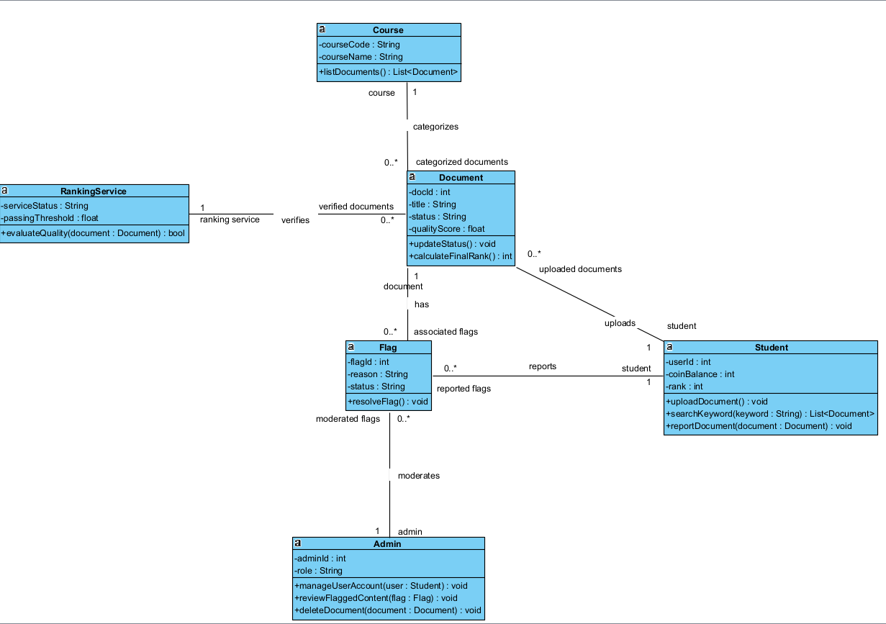
Figure 3.3. The class diagram of CampusNote Pro.

Dynamic Models
Dynamic models describe the dynamic behavior of the system, showing how it works over time and how different parts interact. This activity diagram illustrates the core workflow of the gamified document verification process in the CampusNote Pro system. It details the step-by-step sequence starting from a student uploading a draft, through the external AI Ranking Service's evaluation, and concluding with the conditional logic to either publish the note and award CampusCoins or reject the file.

Scenario: Successful Gamified Document Upload and Rank Progression
Activity Flow
- Start
- Student logs into CampusNote Pro.
- Student navigates to the target Faculty and Course Code.
- Student uploads the PDF study note.
- System saves the document in "Draft" status.
- AI Ranking Service evaluates the document quality.
- Decision: Check Quality Score
  - [Branch: score > 80] System changes document status to "Published".
  - (Note: If score <= 80, the system rejects the document, notifies the user, and the flow ends).
- System awards CampusCoins to the student's balance.
- System evaluates the new coin balance against rank thresholds.
- Decision: Check Rank Threshold
  - [Branch: balance >= threshold] System upgrades the student's virtual rank.
  - (Note: If balance < threshold, the flow directly ends).
- End

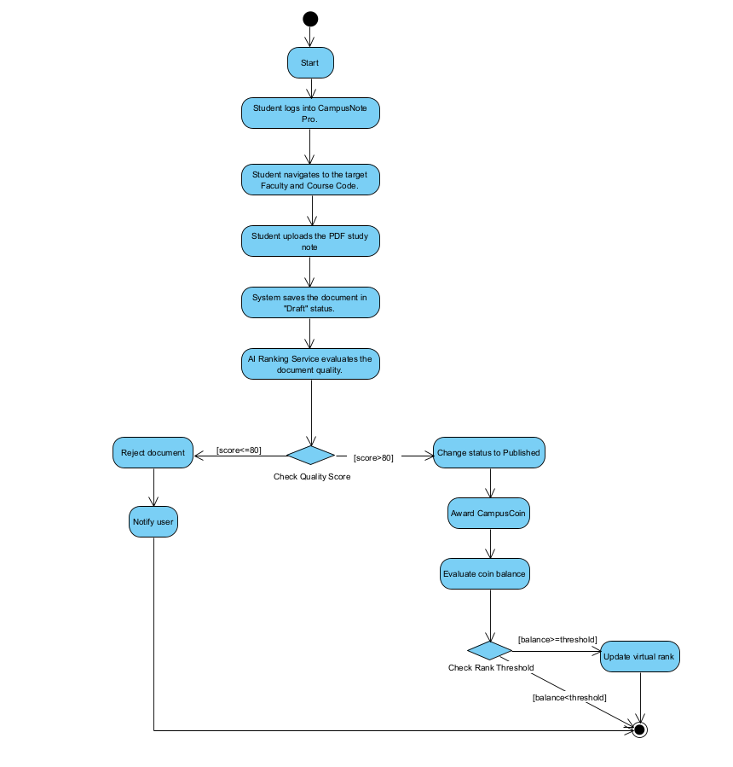
Figure 3.4. The activity diagram of the CampusNote Pro document verification and gamification process.

This sequence diagram illustrates the dynamic object interactions during the document upload and verification process. It details the sequential flow of synchronous and asynchronous messages between the Student, Web UI, Backend API, Database, and the external AI Service, including the alternative condition (alt) block for successful publication or rejection based on the AI quality score.
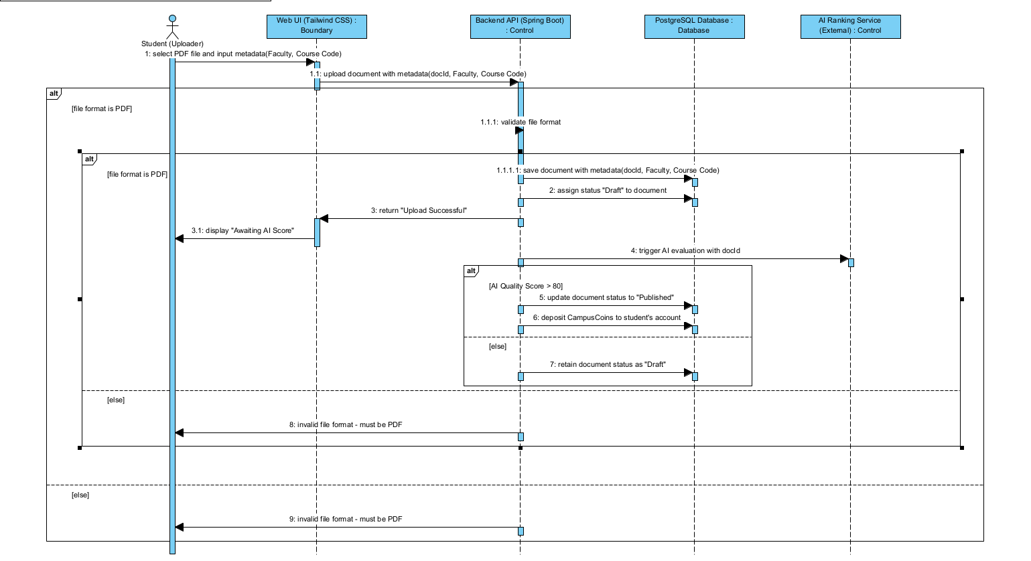
Figure 3.5. The sequence diagram.

Component, Package and Deployment Models
This deployment diagram shows the physical execution environments and hardware nodes of the CampusNote Pro platform. It illustrates how the Student PC connects to the Heroku Cloud Platform via HTTPS, which hosts the Spring Boot application and PostgreSQL database, while securely communicating with a separate server running the external AI Engine.

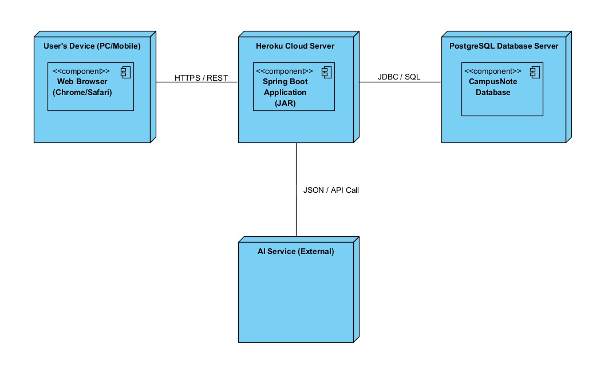
Figure 3.7. The Deployment Diagram of CampusNote Pro.

The package diagram demonstrates the logical grouping of the system's classes into distinct modules. It highlights the separation of concerns by dividing the system into UI, API, Security, and Database packages, ensuring a modular and maintainable codebase.
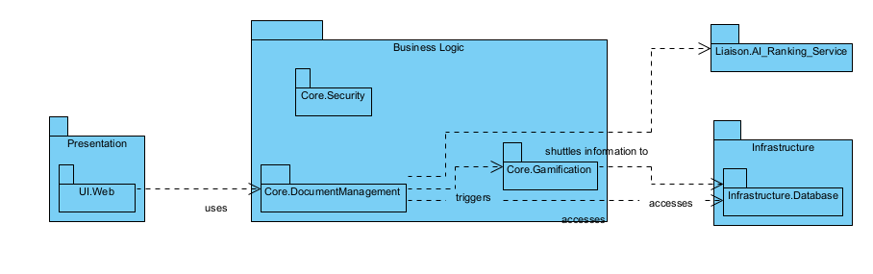
Figure 3.8. The Package Diagram of CampusNote Pro.

This component diagram illustrates the main software modules of the system and their dependencies. It highlights how the Web UI component interacts with the central Backend API component, which in turn orchestrates data exchange with the external AI component for document evaluation and the Database component for storage.

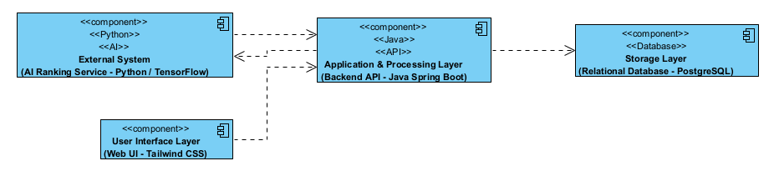
Figure 3.9. The component diagram of CampusNote Pro.

System Architecture
This system architecture diagram presents the high-level layered structure of CampusNote Pro. The architecture is organized into four main layers: the User Interface Layer (Tailwind CSS), the Application & Processing Layer (Java Spring Boot), the Storage Layer (PostgreSQL), and an External System running the AI Ranking Service (Python). It illustrates the clear flow of data, such as document uploads, AI scoring requests, and persistent data storage operations across these isolated layers.
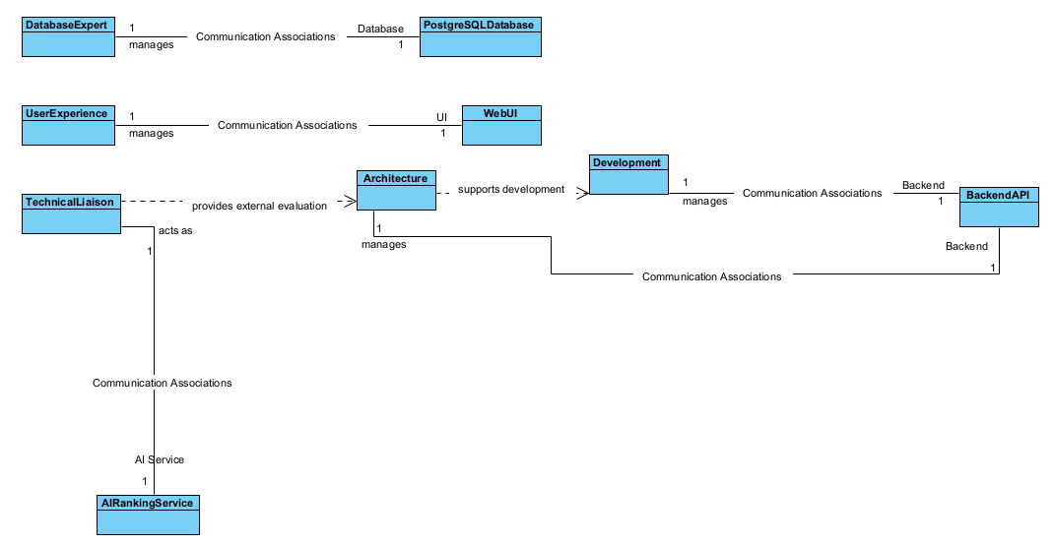
Figure 3.6. The high-level layered system architecture diagram of CampusNote Pro.

User Interfaces
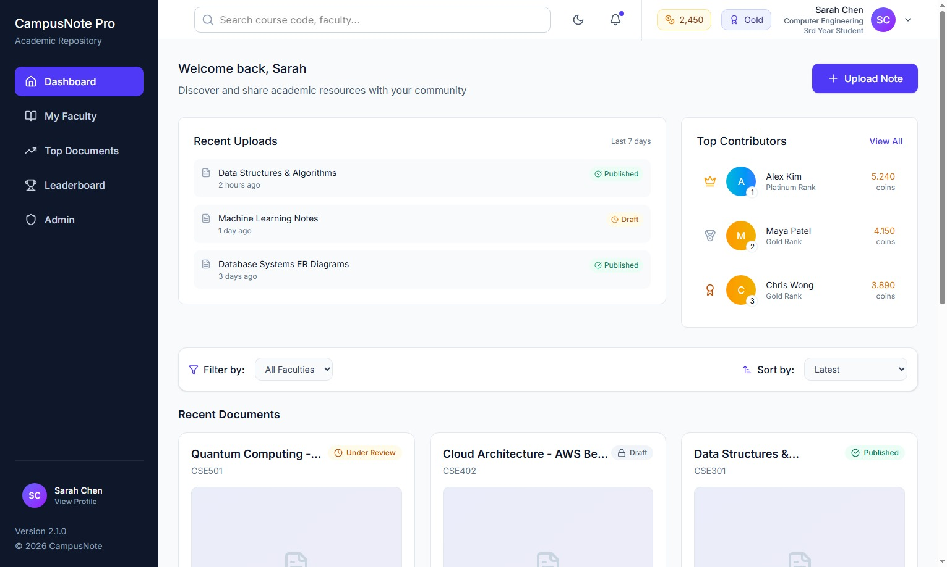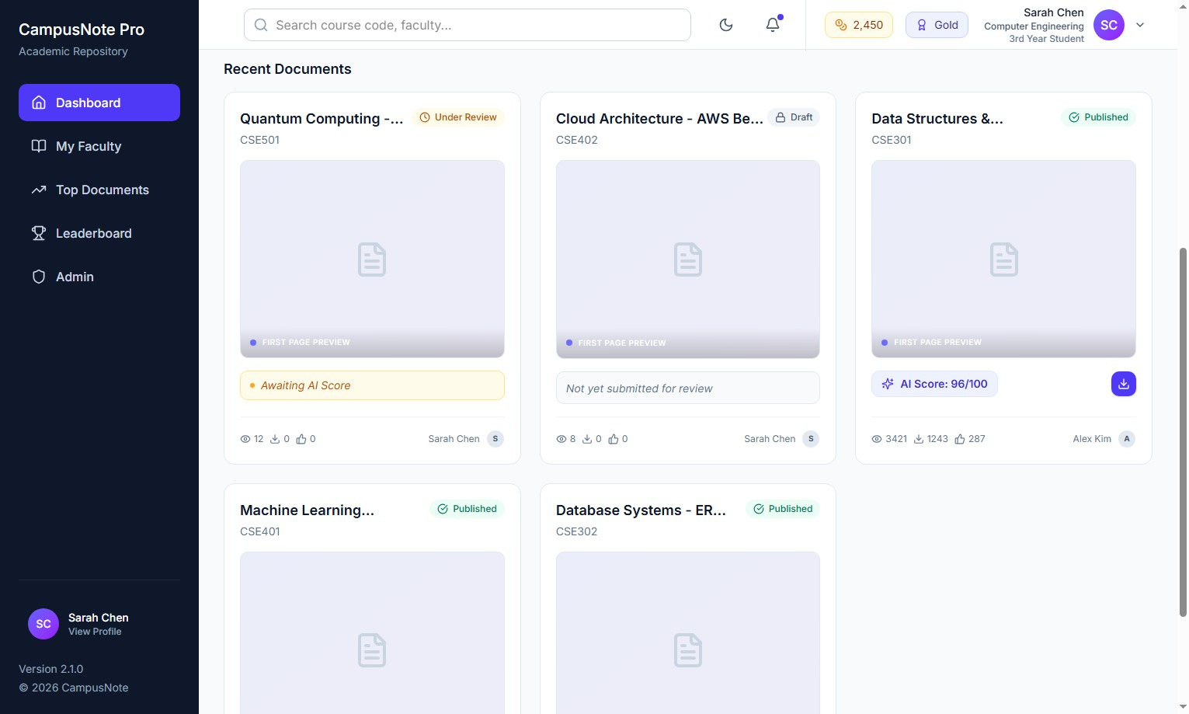

Purpose: This screen serves as the primary central hub for students to discover academic resources, track their gamification progress, and monitor the latest community contributions.

Information Displayed: It presents the user's current CampusCoin balance and virtual rank in the top navigation. The main content area features a "Top Contributors" leaderboard, a list of recent uploads, and detailed document cards. These cards display a first-page thumbnail preview , course codes, academic engagement metrics (views/downloads), and distinctly color-coded verification statuses such as Draft and Published. For "Published" notes, the AI Quality Score is also visibly displayed.
User Actions: Users can utilize the top search bar to find specific keywords, apply Faculty filters, and sort the document feed. They can also initiate a new document submission via the "Upload Note" button , or click thedistinct download icon on verified "Published" documents to retrieve study materials.

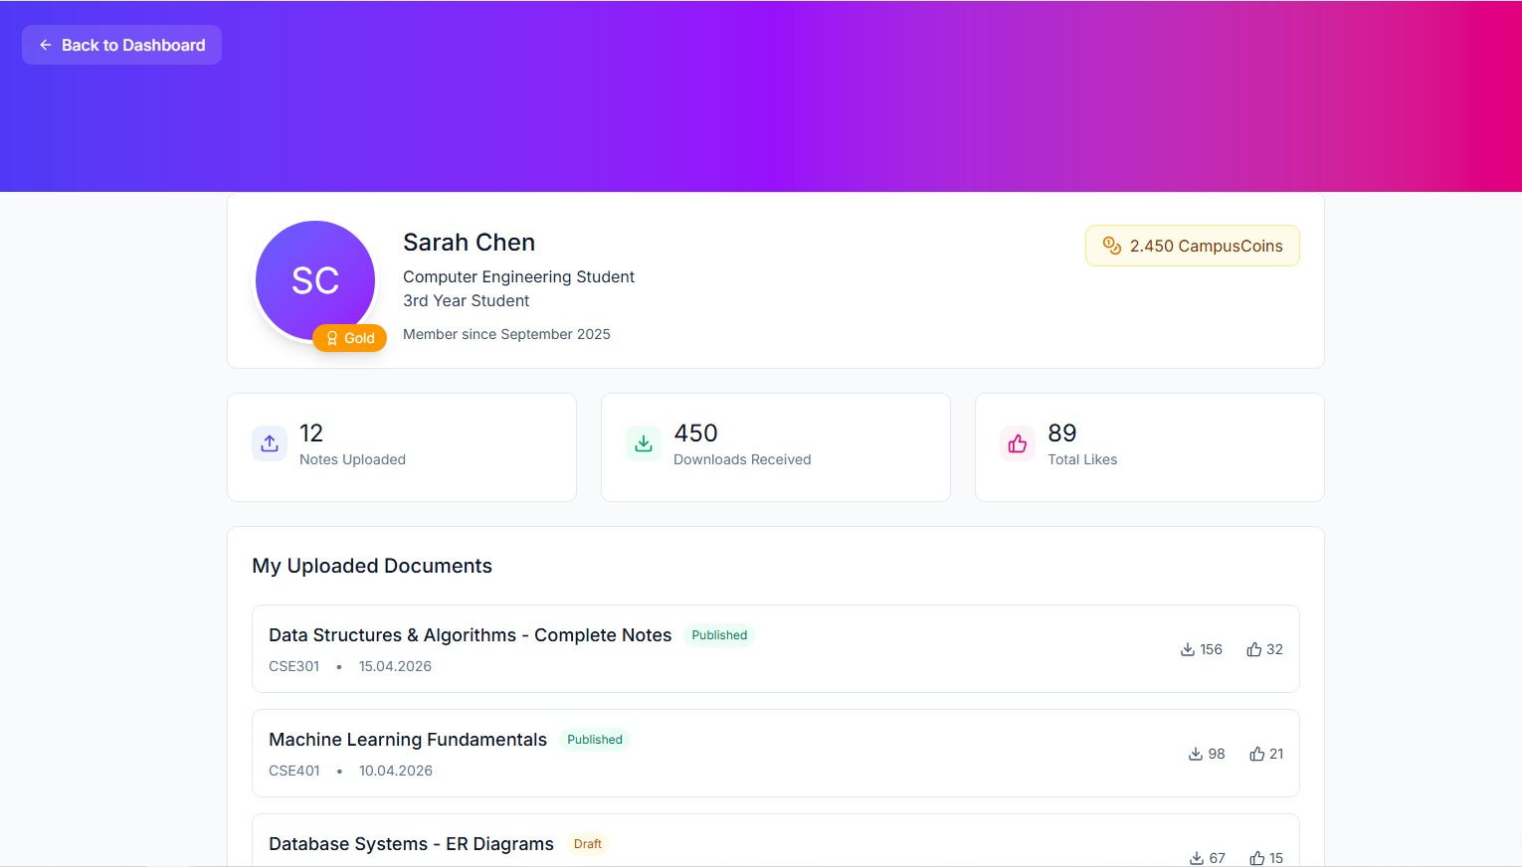

Figure 3.11. User Profile Screen
- Purpose: This screen provides a personalized overview of a student's academic contributions and their gamification progress within the platform.
- Information Displayed: It displays the user's current CampusCoin balance, rank badge (e.g., Gold), overall engagement statistics (total notes uploaded, downloads received, likes), and a detailed history of their uploaded documents.
- User Actions: The user can monitor the verification status of their submitted documents, track the engagement metrics of their published notes, and navigate back to the main dashboard.
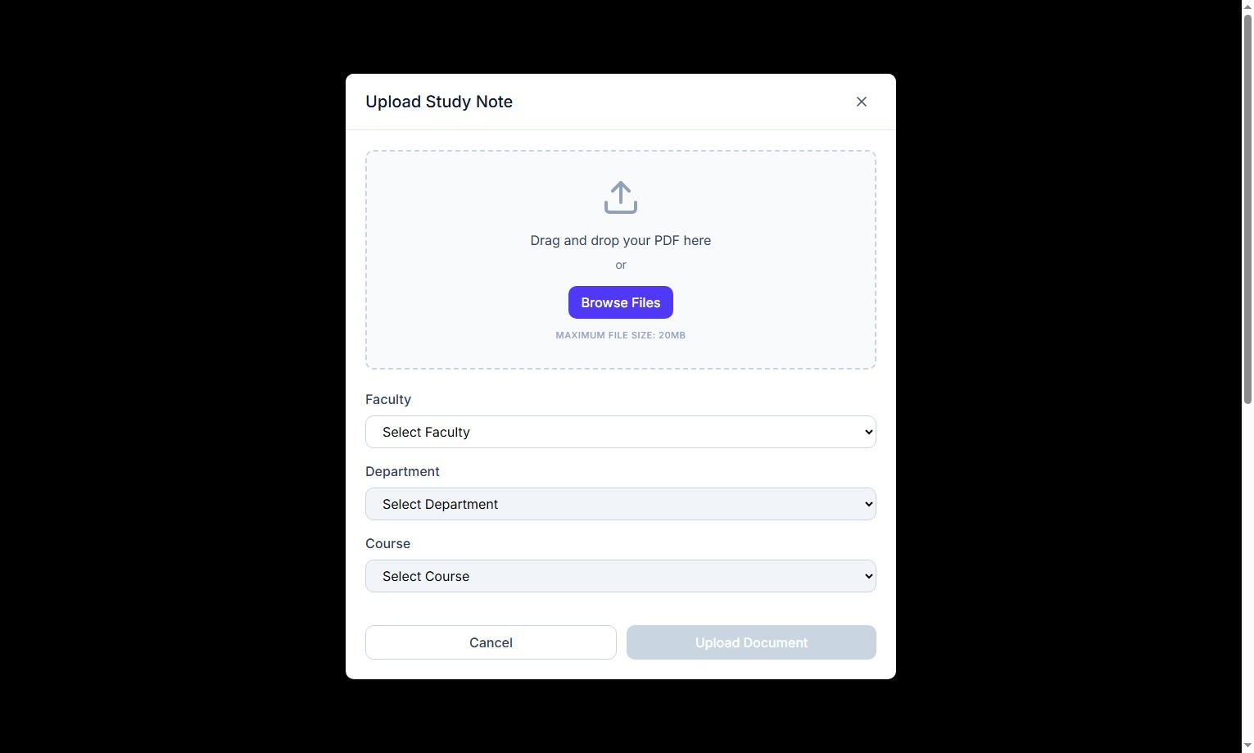
Figure 3.12. Document Upload Screen [Buraya ui-file.jpeg görselini yapıştırın]
Purpose: This interface allows students to submit their academic study notes to the system for AI verification.
Information Displayed: It features a drag-and-drop file upload area specifically indicating the required PDF format and a clear helper text stating the maximum file size limit of 20MB. Additionally, it presents hierarchical dropdown menus for precise academic categorization.
User Actions: The user can browse or drag a PDF file into the dropzone, strictly categorize the document by selecting the target Faculty, Department, and Course, and click the "Upload document" button to send the file into the "Draft" status for subsequent AI evaluation.
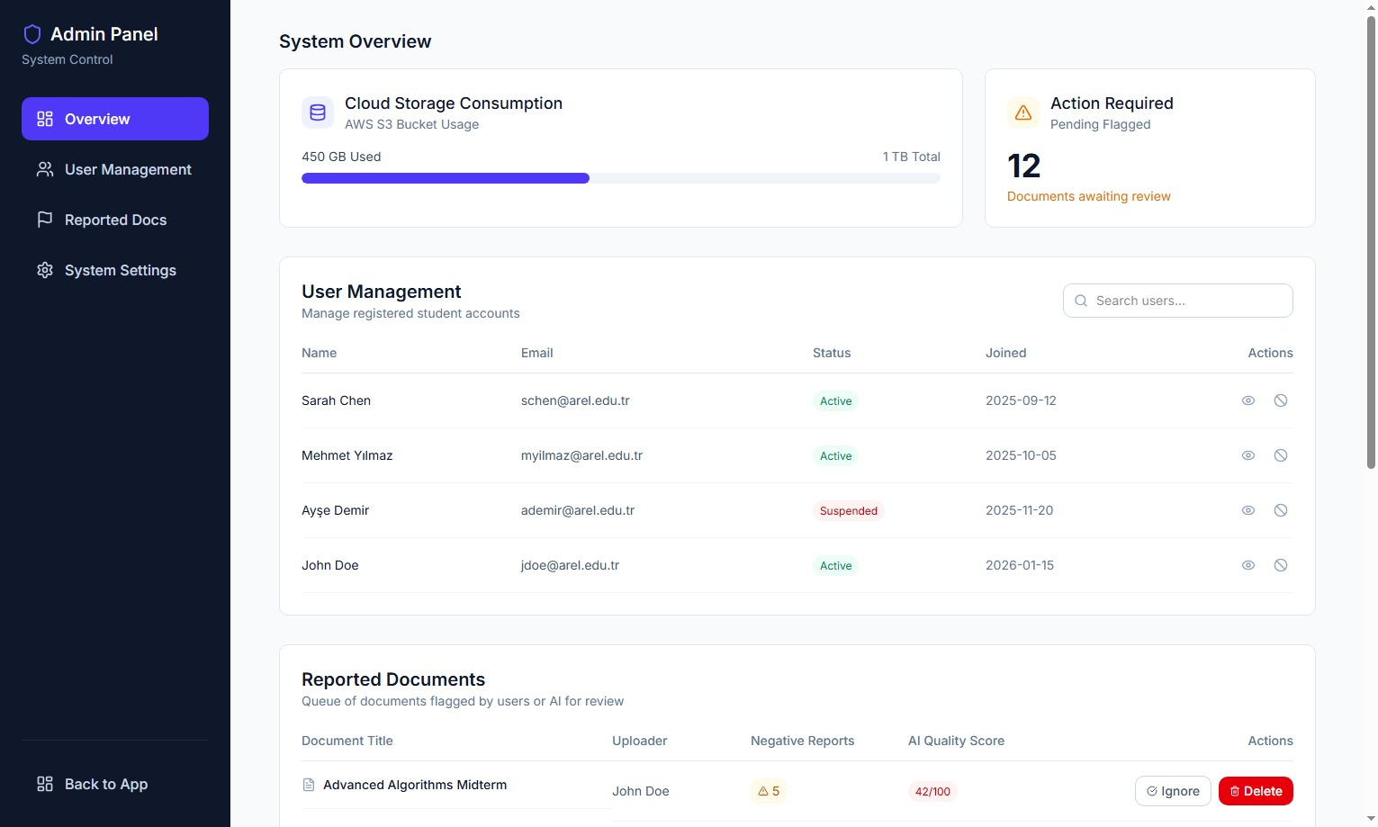
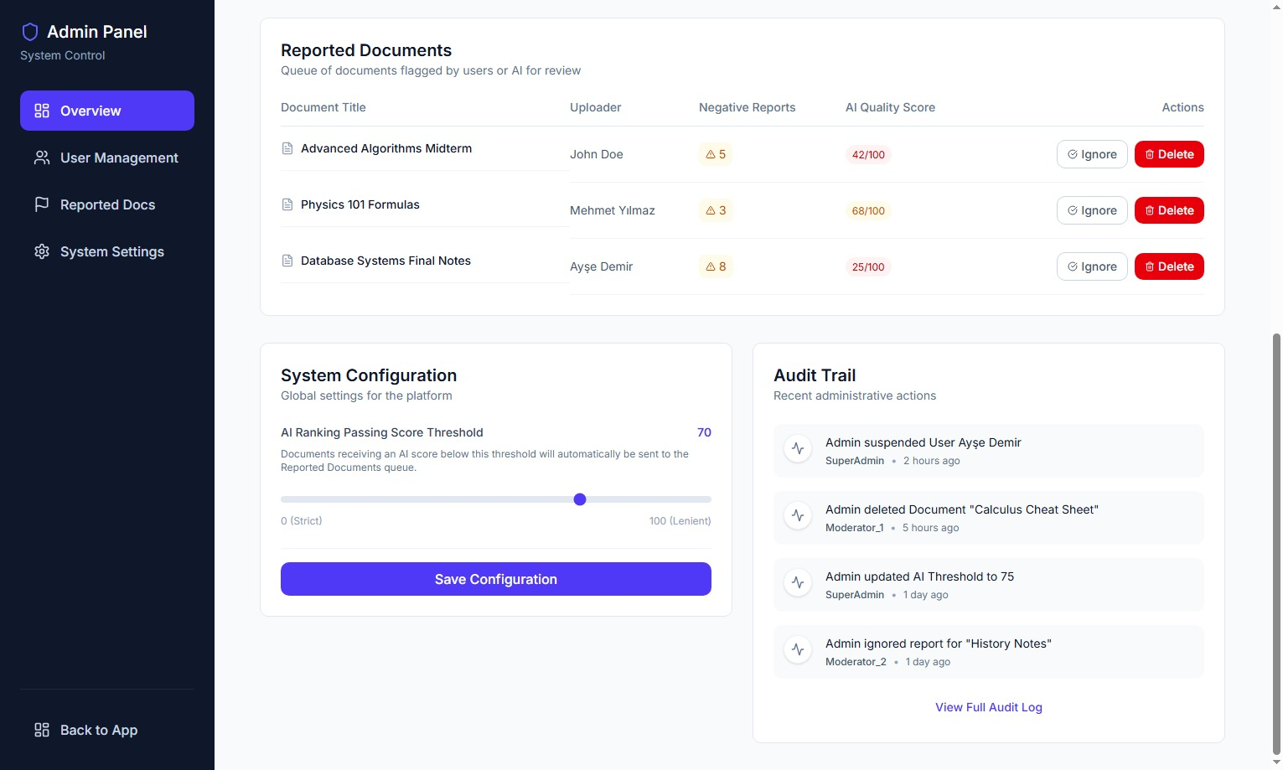
Purpose: This screen serves as a restricted, centralized control panel for authorized system administrators to manage student accounts, moderate flagged academic content, and configure core platform settings.
Information Displayed: The dashboard is divided into several key data widgets:
- System Overview: Displays real-time Cloud Storage Consumption and an alert for the number of pending flagged documents awaiting review.
- User Management: A data table listing registered student accounts (using @arel.edu.tr emails), their registration dates, and their current account status (e.g., Active, Suspended).
- Reported Documents: A queue of documents flagged by users or the AI, showing the document title, uploader, number of negative reports received, and the AI Quality Score.
- System Configuration & Audit Trail: Shows the current "AI Ranking Passing Score Threshold" alongside a read-only list of recent administrative actions (e.g., document deletions, user suspensions) to ensure traceability.
User Actions: Administrators can search for specific users and temporarily suspend their accounts. In the moderation queue, they can evaluate flagged items and choose to either "Delete" the document (for academic integrity violations) or "Ignore" the report. Additionally, admins can use the slider to adjust the global AI passing score threshold and save the new configuration.

Minimum Requirements
To satisfy the core objectives of the CampusNote Pro platform within the 10-week development timeline, the following elements constitute the mandatory minimum project scope:

Modeling Deliverables (The Analysis MVP)
Per the professor’s guidelines, the system analysis must be supported by a specific minimum set of UML artifacts:
- Use Case Models: One comprehensive Use Case Diagram and a minimum of four detailed textual descriptions covering Authentication, Upload, AI Verification, and Search/Retrieval.
- Data Model: One Entity-Relationship (ER) Diagram representing the relational persistence layer in 3NF, including User, Faculty, Course, and Document entities.
- Dynamic Model: One Activity Diagram illustrating the "Draft-to-Published" state machine and one Sequence Diagram detailing the REST API interaction with the external AI service.
- System Architecture: One high-level Layered Architecture diagram showing the client-server boundaries between the Tailwind CSS frontend and Spring Boot backend.
- User Interfaces: At least three high-fidelity UI mockups (Dashboard, Upload Modal, and Admin Panel).

Core Functional MVP (The Software MVP)
The implementation phase must deliver these high-priority (Must Have) behaviors to be considered successful:
- Academic Hierarchy: A working directory structure that categorizes PDFs strictly by Faculty and Course Code.
- AI-Driven Lifecycle: Automated transition of documents from "Draft" status to "Published" based on a score received from the Python-based AI service.
- Gamified Incentives: Immediate distribution of CampusCoins to user accounts upon successful document publication.
- Search & Retrieval: A keyword-based search engine that exclusively displays verified, high-quality materials.

Technical Constraints
The final product must adhere to these environmental requirements for the Phase 2 audit:
- Deployment: A functional SaaS application hosted on the Heroku cloud platform.
- Stack: Backend developed in Java Spring Boot with data persistence in PostgreSQL.
- Security: All user passwords must be hashed using BCrypt before database entry.

- Requirements Validation
Requirements validation is performed after requirements elicitation and analysis to ensure that the defined requirements for CampusNote Pro are correct, complete, verifiable (testable), and ready for the Agile implementation phase.

Validation Approach
- The requirements for CampusNote Pro were validated using the following methods:
  - Team Reviews (Scrum Refinement): All team members (Project Leader, Developers, and Tester) reviewed the functional and non-functional requirements to ensure alignment with the system architecture.
  - Testability Check (BDD/TDD Alignment): As part of the QA process, every functional requirement was evaluated to ensure it could be translated into executable JUnit and JBehave test scenarios.
  - Proxy Stakeholder Evaluation: The team acted as proxy students (uploaders and consumers) to verify that the requirements solve the targeted "Information Silo" and "Temporal Decay" problems.

Validation Results

- Correctness
  - The requirements directly address the core problem of academic information loss at Istanbul Arel University.
- Completeness
  - All essential phases of the document lifecycle are covered:
  - Upload & Categorization (Draft status)
  - AI Verification (Ranking algorithm)
  - Publication & Rewarding (Published status)
  - Search & Download
  - Edge cases and alternative flows are properly defined in the Use Cases.
- Consistency
  - The academic hierarchy is consistently maintained across Functional Requirements, ER Data Models, and Use Cases.
  - Terminology is used uniformly throughout the documentation without contradiction.
- Clarity
  - Requirements are written unambiguously.
  - Non-Functional Requirements (NFRs) use strict, measurable metrics rather than vague adjectives.
- Realism
  - The technology stack and deployment environment (Heroku) are fully feasible for the 10-week development timeline.
  - By excluding native mobile app development (CON-TECH-05) and focusing on a responsive web UI, the project scope remains realistic and manageable.
- Traceability
  - Every requirement possesses a unique identifier (e.g., FR-UC-05, NFR-DOC-04).
  - All 'UC' tagged functional requirements are explicitly traced to their fulfilling Use Cases to ensure 100% technical verification.

Acceptance Criteria
- The following table defines the measurable conditions that must be satisfied for the core requirements of CampusNote Pro to be accepted as complete.

Table 4.1. Acceptance criteria for core requirements.

Requirement ID | Acceptance Criteria
FR-UC-01 | The system shall successfully authenticate students using valid university credentials and reject invalid ones with an error message.
FR-UC-02 | The system shall successfully accept and store uploaded study notes strictly in PDF format, rejecting all other file types.
FR-SC-03 | The system shall accurately tag and categorize successfully uploaded documents by their designated Faculty and Course Code metadata.
FR-UC-04 | The system shall automatically assign a "Draft" status to all newly uploaded documents upon successful submission.
FR-UC-05 | The system shall successfully execute the AI-based Academic Ranking Algorithm on documents currently holding a "Draft" status.
FR-UC-06 | The system shall transition a document's status from "Draft" to "Published" exclusively when the AI algorithm assigns a passing score of > 80.
FR-UC-07 | The system shall permit users to successfully download PDF documents that possess a "Published" status.
FR-UC-08 | The system shall return search results matching the user's keyword and strictly display only documents that have a "Published" status.
FR-UC-09 | The system shall correctly deposit CampusCoins into the uploader's account immediately following a successful status transition to "Published".
NFR-DOC-01 | The application hosted on Heroku shall demonstrate an uptime availability of at least 99.9% during monitoring.
NFR-DOC-04 | The system shall fetch and render a document preview in <= 2 seconds under normal server load.
NFR-TECH-03 | The PostgreSQL database shall store 100% of user passwords as BCrypt hashes; no plain-text passwords shall be saved.

The requirements for CampusNote Pro have been rigorously validated. They are confirmed to be correct, complete, consistent, and highly testable. The clear definition of measurable Acceptance Criteria ensures that the Quality Assurance (QA) team can seamlessly proceed with writing automated BDD/TDD test suites, providing a solid, verified foundation for the Agile Scrum implementation phase.

- Traceability
The Traceability Matrix ensures that every high-level student requirement for CampusNote Pro is reflected in the system design and verified through rigorous testing. This alignment prevents "requirement leakage" and guarantees that the final platform delivered on Heroku meets 100% of the initial project goals.

The following matrices establish a bi-directional link between our elicitation artifacts and our Quality Assurance (QA) suite, providing a comprehensive representative sample of the system's core subsystems. For each requirement, it identifies:

- Use Case: The behavioral model defined in Section 3.
- Component / Module: The specific part of the Java/Spring Boot backend or Tailwind CSS frontend responsible for the feature.
- Test Case: The specific JUnit (TDD) or JBehave (BDD) test suite that validates the functionality.

Traceability Matrix

Table 5.1. Functional traceability matrix.

Requirement ID | Description | Associated Use Case | Component / Module | BDD / Automated Test Case
FR-ST-01 | University Email Auth | UC-01 Authenticate User | Auth Module (Spring Security) | testRejectNonArelEmailDomains()
FR-ST-11 | Upload History Display | UC-02 Upload Document | UI.Web & Core.DocManagement | testFetchUserUploadHistory()
FR-ST-15 | PDF Format Enforcement | UC-02 Upload Document | UI.Web & Core.DocManagement | testRejectNonPdfUploads()
FR-ST-27 | AI Quality Scoring | UC-03 Verify, Publish & Reward | Liaison.AI_Ranking_Service | testScoreCalculationLogic()
FR-DOC-28 | AI Publication Rule | UC-03 Verify, Publish & Reward | Document State Machine | testStatusChangesToPublished()
FR-ST-34 | CampusCoin Distribution | UC-03 Verify, Publish & Reward | Core.Gamification | testAddCoinsOnSuccessfulPublish()
FR-ST-40 | Verified Search Filter | UC-04 Keyword Search | Core.DocManagement | testSearchExcludesDrafts()
FR-ST-44 | Secure File Retrieval | UC-04 Keyword Search | Core.DocManagement / AWS S3 | testDownloadGeneratesS3Link()
FR-ST-50 | Admin User Suspension | UC-04 Keyword Search | Core.Security / Admin Panel | testSuspensionRevokesLogin()

Non-Functional Traceability Matrix

Table 5.2. Non-functional traceability matrix.

Requirement ID | Description | Component / Infrastructure | Verification Method
NFR-DOC-65 | 99.9% Operational Uptime | Heroku Cloud Environment | Continuous Ping/Uptime Monitoring API
NFR-ST-66 | 100% Verification Integrity | Liaison.AI_Ranking_Service | Automated System Integration Test
NFR-ST-67 | BCrypt Password Security | Infrastructure.Database (PostgreSQL) | verifyPasswordIsHashedInDatabase()
NFR-ST-68 | Automated Data Backups | Infrastructure.Database (PostgreSQL) | Cron Job Log Audit
NFR-ST-69 | Preview Latency (≤ 2.0s) | Core.DocManagement / AWS S3 | Apache JMeter Load & Stress Test
NFR-ST-71 | AI Engine Throughput | Liaison.AI_Ranking_Service | JMeter Performance Profiling (10MB File)

- Conclusion
In this project, the software requirements for CampusNote Pro, a centralized Software as a Service (SaaS) platform, have been comprehensively analyzed and formally defined. The primary motivation was to solve the critical issue of "Information Silos" and the continuous loss of valuable academic study materials distributed across transient social media groups at Istanbul Arel University. Through a rigorous Requirements Engineering process adhering to SWEBOK v4.0 standards, stakeholder needs were elicited, resulting in a robust system designed to hierarchically archive, verify, and share academic documents.

During the requirements analysis phase, core functionalities such as hierarchical document categorization (Faculty, Department, Course Code), AI-based quality verification, and a gamified reward system (CampusCoins) were established. To ensure structural integrity, various system models—including Use Case descriptions, Entity-Relationship (ER) data models, class diagrams, dynamic behavioral models (specifically Sequence and Activity diagrams), and high-level client-server architectural diagrams—were created using Visual Paradigm. Furthermore, a strict Traceability Matrix was developed to link every functional requirement directly to executable JUnit and JBehave test cases, establishing a highly verifiable foundation for the Quality Assurance (QA) team and the upcoming Agile Scrum implementation.

Key system design decisions included adopting a layered architecture with a RESTful Java/Spring Boot backend, an external Python/TensorFlow service for the AI Ranking Algorithm, a responsive Tailwind CSS frontend, and a PostgreSQL database, all strategically targeted for deployment on the Heroku cloud infrastructure. The system modeling proceeded with necessary assumptions regarding stable internet connectivity and the autonomous capability of the AI ranking algorithm to process documents. To maintain a realistic and achievable 10-week development timeline, the project constraints explicitly excluded native mobile application development, focusing entirely on a mobile-first web interface.

In the future, CampusNote Pro can be further expanded and improved. Potential enhancements include developing dedicated native iOS and Android applications to maximize student accessibility, implementing real-time collaborative document editing tools, and integrating the platform directly with Istanbul Arel University's official Learning Management System (LMS) to synchronize course codes automatically.

- References

[1] IEEE Computer Society, SWEBOK v4.0: Guide to the Software Engineering Body of Knowledge. IEEE, 2024. [Online]. Available: https://www.computer.org/volunteering/boards-and-committees/professional-educational-activities/se-body-of-knowledge
[2] M. Seidl, M. Scholz, C. Huemer, and G. Kappel, UML @ Classroom: An Introduction to Object-Oriented Modeling, 1st ed. Vienna, Austria: Springer, 2015.
[3] Object Management Group (OMG), "Unified Modeling Language (UML) Specification v2.5.1," Dec. 2017. [Online]. Available: https://www.omg.org/spec/UML/2.5.1/
[4] C. Walls, Spring in Action, 6th ed. Shelter Island, NY, USA: Manning Publications, 2022.
[5] J. M. Hellerstein, M. Stonebraker, and J. Hamilton, "Architecture of a Database System," Foundations and Trends in Databases, vol. 1, no. 2, pp. 141–259, 2007.
[6] A. Wathan, Tailwind CSS: Up and Running.
[7] A. Vaswani et al., "Attention is all you need," in Proc. Advances in Neural Information Processing Systems (NeurIPS), 2017, pp. 5998–6008.

- Descriptions, Abbreviations, and Dictionary

Descriptions
Table 8.1. Descriptions.
Word or Concept | Description
CampusCoin | A virtual reward unit given to students to encourage the upload of high-quality study notes.
Draft Status | A temporary state for an uploaded document awaiting evaluation by the Artificial Intelligence algorithm.
Published Status | The state of a document that has successfully passed the AI evaluation (scoring 80 or above) and is publicly accessible in the system.
Gamification | A rank and point system integrated into the platform to increase user engagement and participation.
SaaS | (Software as a Service) A software distribution model where the platform is hosted on the cloud (Heroku) and accessed via a web browser.

English Abbreviations
Table 8.2. English abbreviations.
Abbreviation | Meaning
AI | Artificial Intelligence
API | Application Programming Interface
DB | Database
UI | User Interface
READ | Requirements Elicitation and Analysis Document

